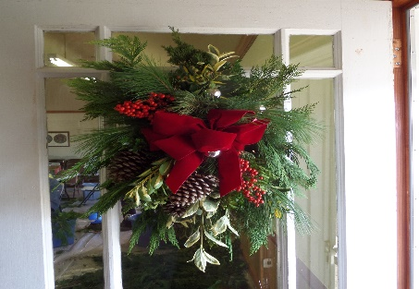
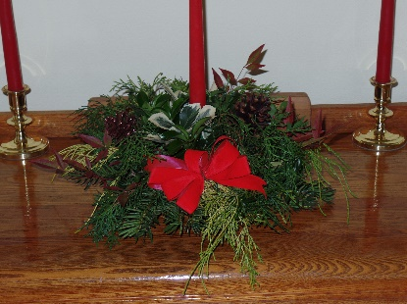
THE SPADE & TROWEL GARDEN CLUB
SEAFORD, DE
www.seafordspadeandtrowelgardenclub.org

2019 HOLIDAY EVERGREENS SALE
ORDER FORM—December 2nd & 3rd

ORDERED BY: ___________________________________________________________________________________

PHONE: __________________________________________ PICKUP (Circle) Monday or (Circle) Tuesday

EMAIL ADDRESS:________________________________________________________________________________

PRODUCT | QUANTITY | PRICE EACH | TOTAL FOR ITEM
Single Candle Centerpiece | ______________ | $15 | __________________
Double Candle Centerpiece | ______________ | $25 | __________________
Swag, Mixed Greens (Apx. 20”) | ______________ | $25 | __________________
Mound (Apx. 40”- 48” Length) | ______________ | $35 | __________________
WREATHS (Apx. 22”)
- Mixed Greens | ______________ | $35 | __________________
- Boxwood | ______________ | $40 | __________________
- Magnolia | ______________ | $50 | __________________
TOTAL DUE |  |  | __________________
**In addition to the above products being sold there will be a variety of Christmas Mugs for sale at the pickup center. “Mugs of Cheer” items make a great teacher or hostess gift and will be sold on a first come first sold basis at the pickup center. $8.00 each or 3 for $20.00.

_______ PAID Circle One (Cash or Check payable to “S&T Garden Club”)

_______ PAYMENT AT PICK-UP (Cash or Check made payable to “S&T Garden Club”)

Solicited By: (Garden Club Member) __________________________________________________
----------------------------------------------------------------------------------------------------------------
SPADE & TROWEL GREENS SALE PICK UP LOCATION AND TIMES

Monday, December 2nd from 3-6 PM “Ross Station” Across from Library
Tuesday, December 3rd from 3-6 PM “Ross Station” Across from Library

NEW LOCATION: This new building is across from the library. The official address is 585 N. Market Street, Ext. There is a parking lot located directly off Market Street and a pickup drive in front of the building. Ross Station at Gov. Ross Plantation

